
A10
Sreenidhi Institute of Science and Technology
(An Autonomous Institution)
Code No: 101ME09
B. TECH. II-Year I-Semester Examinations, December 2015 (Supplementary)
MACHINE DRAWING (ME)

Time: 3 Hours Max. Marks: 70

Note: No additional answer sheets will be provided.

Part-A
Max.Marks:30
Answer any two QUESTIONS.

- Answer all questions (3X5=15 Marks)
- Sketch the conventional representation of Lead, Marble and Cast Iron
- Sketch bevel gear and worm wheel
- Sketch a square thread of pitch 5 mm and nominal diameter 50 mm.

- Draw the front view and top view of a knuckle joint to connect two round rods of diameter 25 mm by taking suitable proportions. (15 Marks)
- Draw (15 Marks)
Sectional view from the front and Top View from above, of the following riveted joints, to join plates of thickness 10 mm:
(i) Double riveted chain lap joint,
(ii) double riveted, double strap, chain butt joint

Part-B (40 Marks)

- The details of an air cock are shown in Fig.1. Assemble the parts and draw,

(i) half sectional view from the front,

(ii) view from the right

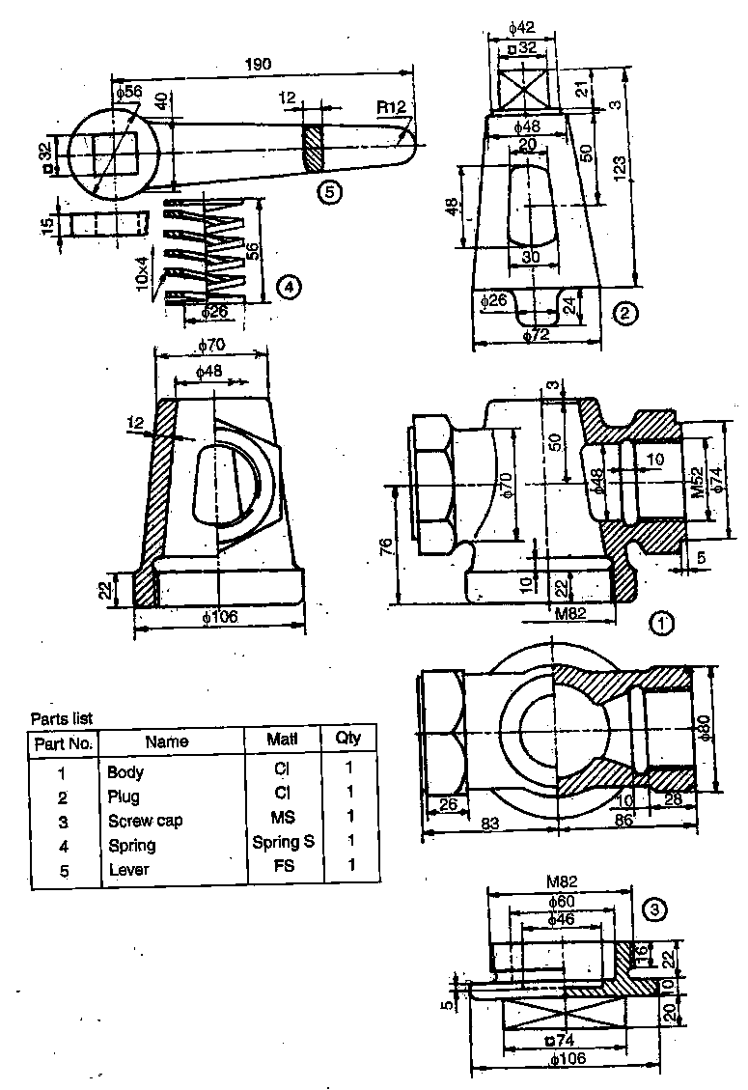

Figure1. Air cock

-- 00 -- 00 --

